Name: Noor-e-Eman
Section D3
Id F2024332038
LAB TASK
Question no 1:
Create a folder Noor-e-Eman-F2024332038
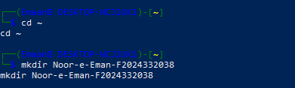
Question 2:
Open the folder Noor-e-Eman-F202332038
and make the folder01 then open the folder01 and make the folder02
then open the folder02 and make the folder03
then open the folder03 and make the folder04
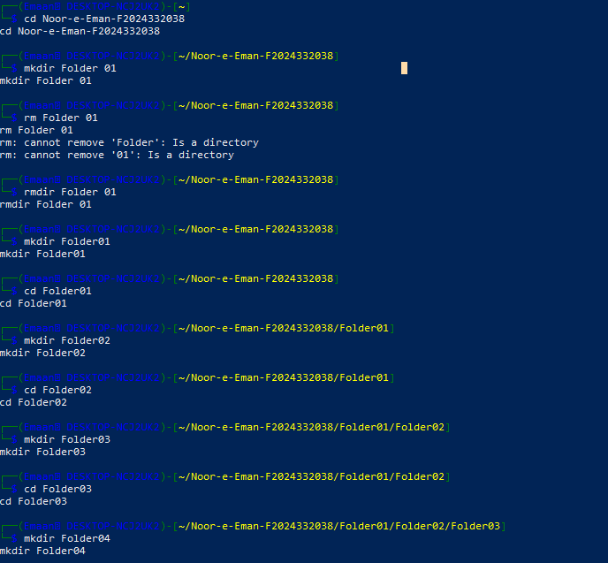
then open the folder04 and make the folder05

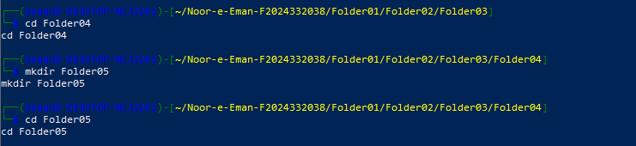
Question 3
Show the folder 1 to 5 recursively
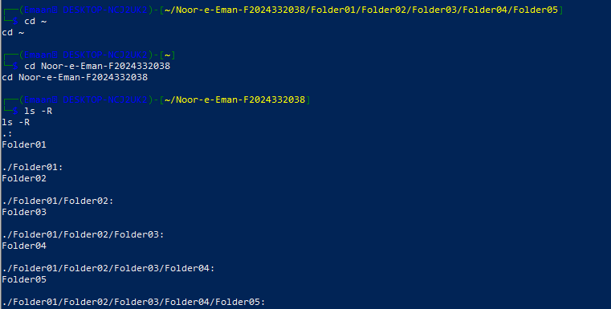
Question 4
Create a file using nano in the folder # 03, and write up your intro...... upto 2 lines
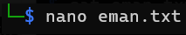
Question 5
The content you saved in the "nano" file, display that content on the console/cmd
